**Connecting GitHub with Posit**

**Posit**

First, log in to Posit Workbench. Select *Tools* from the menu bar at the top of the page and then *Global Options…* from the dropdown.

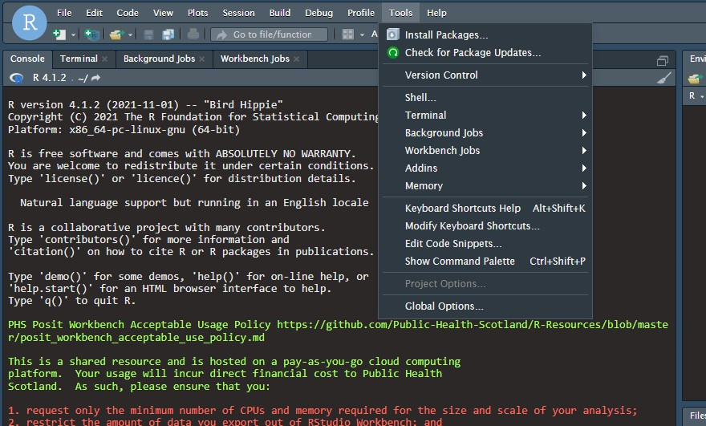

In the window that pops up, select *Git/SVN* on the left and then click on the small box labelled *Create SSH Key…* This will open a new pop-up window called “Create SSH Key”; change the SSH key type to RSA and click *Create*. Close the third pop-up box. You should now be back to the original Global Options box. Click on the tiny blue *View public key* to view your new SSH key. Make sure you copy this to your clipboard, as you will need it for your GitHub account!

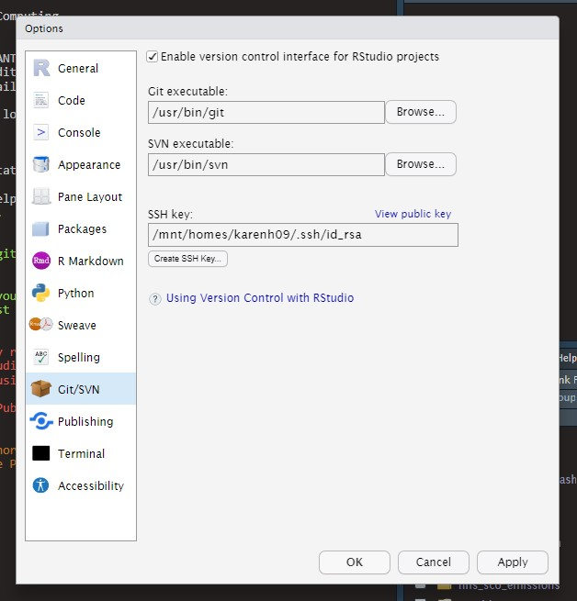 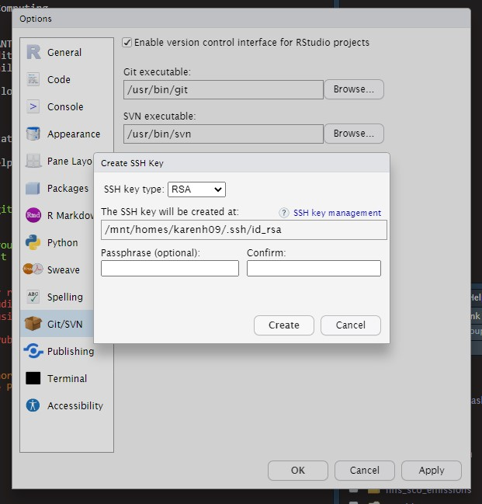

**GitHub**

Log in to your GitHub account and go to your personal settings be clicking on your avatar in the upper right-hand corner of the page and selecting settings from the dropdown menu. This will take you to your profile page. From the menu down the left side of the page, click on *SSH and GPG keys*. The new page will list any SSH keys that you have set up, but for now click on the green *New SSH key* button. 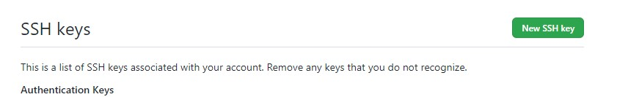

On the *SSH keys / Add new* page, paste the long SSH key copied from Posit Workbench to the box labelled *Key*. Add a short, snappy title and click on the green *Add SSH key* box. 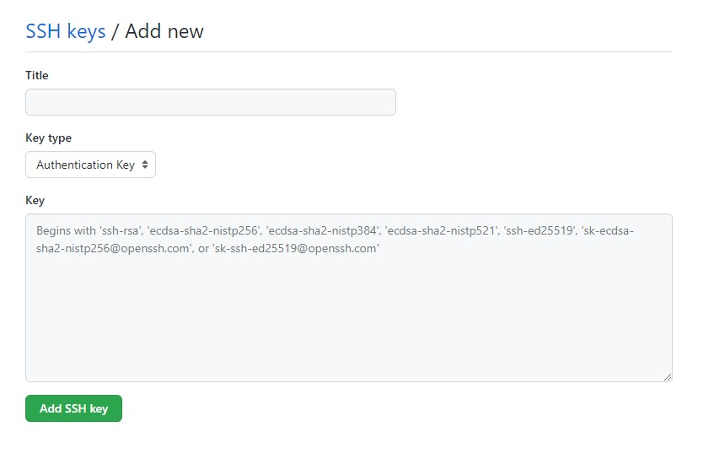

You will receive an email from GitHub confirming that your new key has been added and you can also see any keys added to your GitHub account by going back to the *SSH and GPG keys* section of your personal settings page.

**Posit**

To make sure that you can connect your Posit Workbench to your GitHub account, be sure to go back to Posit and run the following commands in the Console:

install.packages("usethis")  
usethis::use_git_config(user.name = "<Your name>",  
                        user.email = "<yourname>@phs.scot")